100GBAR Cryoview Documentation

**Table of Contents**

Project Setup

Repository Location Page 2

Database Tables Page 2

Log Files Page 2

Command Line Arguments Page 2

Basler Cameras Page 2

Environment Variables for Cameras Page 3

Configuring the Basler Cameras Page 5

Navitar Controller Page 8

Illuminator Page 10

Project Design

Database

Projects, Classes, and Interfaces

Object Interactions

**Project Setup**

**Repository location:**

<http://lle-prod-sdgsvn.lle.rochester.edu/svn/sdg/omega/projects/CryoView_100GBAR/>

**Database Tables:**

Cryoview_Filltube_Config

**Log Files:** The program creates a log file to log the activities of the program for use in debugging errors. Before the program will run, a folder must be created on the desktop for these log files. The program does not create the folder if it does not already exist. The folder should be called “Cryoview2_Log_Files” like in the example:

\\profiles\Users$\tlea\Desktop\Cryoview2_Log_Files

**Command Line Arguments:** No command line arguments are needed to run the program in production mode using the default location of 1. As a developer, the following command line arguments should be added:

/dev:true Tells the program to run as a developer and uses the TFABT database

/location:# Replace the # with the location number used for database entries. Note that 1 is the default location and is reserved for the production entries.

**Basler Cameras:** This program uses two Basler cameras for the X and Y optical inputs. In order to use the SDK for the cameras, PylonViewer must be installed and it must be the same version as the SDK in use. Database entries are needed to specify which camera is being used. Database entries for the camera are in the Cryoview_Filltube_Config database and have the following format:

CFC_Location is the location number plus the camera axis (i.e. 0X )

CFC_Hardware = OpticalCamera

Entries are needed for each of the following CFC_Setting_Name rows and the corresponding values should be placed in CFC_Setting_Value:

SerialNumber

IPAddress

MaxPixelValue

MaxGain

MinGain

PixelFormat

Information for the above settings can be found for each camera using Pylon Viewer or in the user manual. For Emulated cameras use the following:

SerialNumber 0815-0000 for first emulated camera, 0815-0001 for second emulated camera

IPAddress Virtual

MaxPixelValue 4095

MaxGain 1023

MinGain 192

PixelFormat Mono8 or Mono12

**Environment Variables for Cameras:** In order for the computer to create emulated cameras to connect to in the program, you will need to have Pylon Viewer installed with camera emulation support:

<https://docs.baslerweb.com/camera-emulation#installing-camera-emulation-support>

and you will need to set a system environment variable:

PYLON_CAMEMU=2

To set an environment variable open the system properties (you can use the Windows search function), go to the Advanced tab, and click the Environment Variables button.

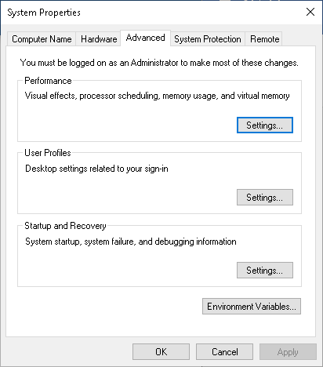

In the new window that opened, under System Variables, click New:

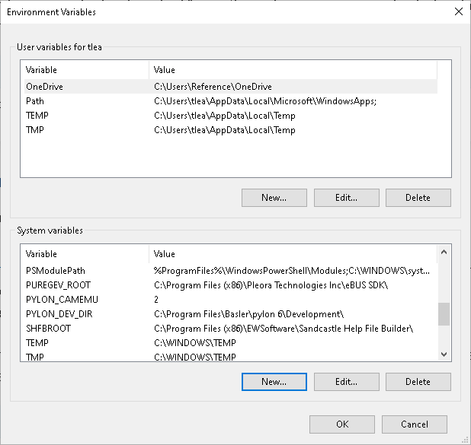

Type the Variable name and Variable value and click OK.

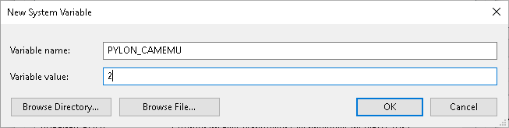

**Configuring the Basler Cameras:** Since the targets are only a small portion of the full field of view for the camera, the Area of Interest (AOI) should be set using the Pylon Viewer tool. The AOI can be set around the center of the field of view by using the Center X and Center Y check boxes, or set manually using the Offset X and Offset Y values. The Width and Height correspond to the width and height values of the AOI.

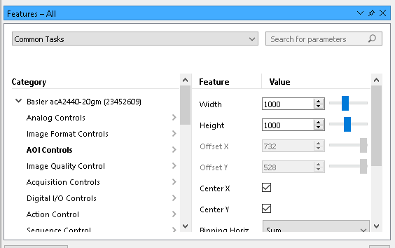

Configuring the AOI is important for saving bandwidth by not sending more image information than is actually going to be used.

The NIC card on the computer running Cryoview should be set to receive jumbo frames to reduce the number of packets that need to be sent for each image. This can be done by going to the Control Panel -> Network and Sharing Center -> Change Adapter Settings -> Properties (of the adapter) -> Configure -> Advanced and setting Jumbo Packets to the largest setting.

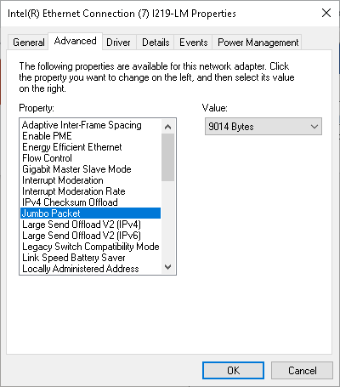

If there are issues with dropped frames, there are also settings on the camera which can be set to reduce the bandwidth used to send images. These are Packet Size, Inter-Packet Delay, and Frame Transmission Delay. Packet Size is the size in bytes of each packet. This helps by using larger packets and sending fewer packets over the network. Inter-Packet Delay is the time waited between sending packets. This helps by staggering the packets over a longer period of time. Frame Transmission Delay is the time waited before starting to send an image. This helps when using multiple cameras taking images simultaneously by not transmitting the images at the same time.

These settings can be found under Transport Layer in Pylon Viewer:

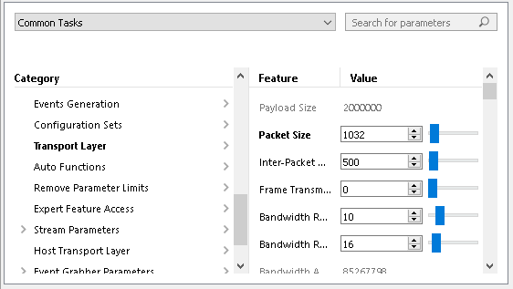

**Navitar Controller:**

Communication to the Navitar is done through a Perle device. The computer will need to have TruePort drivers installed. The Perle can be added to the computer using the TruePort Management Tool.

Add database entries for the Navitar as follows, substituting the information for your setup:

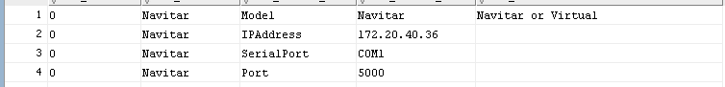

For using a virtual controller, the value for all entries can be set to Virtual.

**Illuminator:**

Programming with the Gardasoft Illuminator is done with the Gardasoft Triniti SDK.

Add database entries for the Illuminator as follows, substituting the information for your setup:

